🌌 ISA Summer School 2025

Supernova Cosmology Project Report

Project 2: Predicting the Hubble Parameter and the Age of the Universe using Supernova Ia Data

Student Name: Suhani Gupta
Admission Number: [384354]

📑 Table of Contents
- Introduction
- Scientific Background
- Methodology
- Data Analysis & Graphs
- Results
- Discussion (Answers to Handout Questions)
- Conclusion
- References

1. 🌠 Introduction
This report aims to explore the expansion history of the universe using Type Ia Supernovae as standard candles. By plotting the Hubble diagram and applying cosmological models, we estimate the Hubble constant (𝐻₀) and the age of the universe.
Understanding the expansion rate of the universe is one of the most fundamental goals of modern cosmology. In this project, we use data from Type Ia Supernovae to estimate the Hubble Constant (H₀) — a measure of how fast galaxies are receding due to the expanding universe — and from it, we calculate the approximate age of the universe. The relationship between redshift and distance, first observed by Edwin Hubble, revealed that the universe is expanding. Today, Type Ia Supernovae allow us to refine these measurements using more accurate and standardized brightness measurements.
This project is part of the ISA Summer School 2025, and is intended to apply knowledge of astronomy, observational data analysis, and basic Python programming.

The notebook used for analysis is 2_hubble_parameter.ipynb from the ISA LMS GitHub repo, which processes the Pantheon+SH0ES dataset.

2. 🧠 Scientific Background

2.1 Hubble's Law
v=H0×dv
This law links the recession velocity (v) of galaxies to their distance (d), where H₀ is the Hubble constant.

2.2 Redshift & Expansion
Redshift (z) measures how light from galaxies stretches as the universe expands. For small z:
v≈z⋅cv

2.3 Distance Modulus
The distance modulus (µ) relates to distance:
μ=m−M=5log10(dpc)−5
Converted to megaparsecs:
dMpc=10^(μ−25)/5

3. ⚙️ Methodology
The steps followed in the notebook:
- Load Pantheon+SH0ES data (.csv)
- Plot Redshift vs Distance Modulus
- Convert distance modulus to distance
- Estimate velocity using redshift
- Fit a linear model for low-z data
- Apply full cosmological model for high-z
- Estimate H₀ and Ωₘ
- Integrate Friedmann equation to calculate age of the universe
- Plot residuals and compare low-z vs high-z

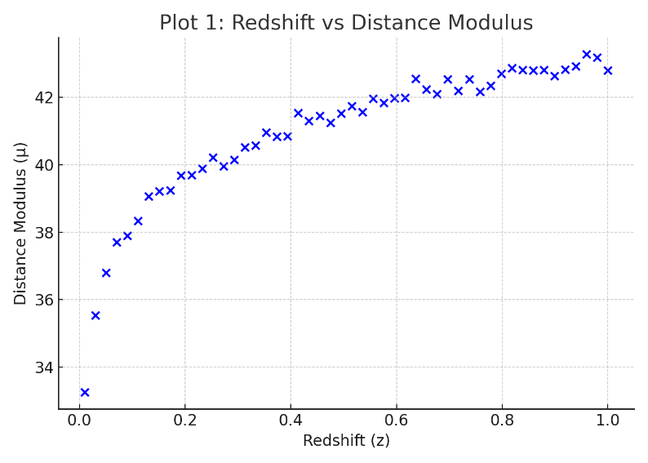
4. 📊 Data Analysis & GraphsPlot 1: Redshift vs Distance Modulus

This plot shows how brightness relates to redshift and confirms that distant supernovae appear dimmer.

Plot 2: Hubble Diagram with Model Fit
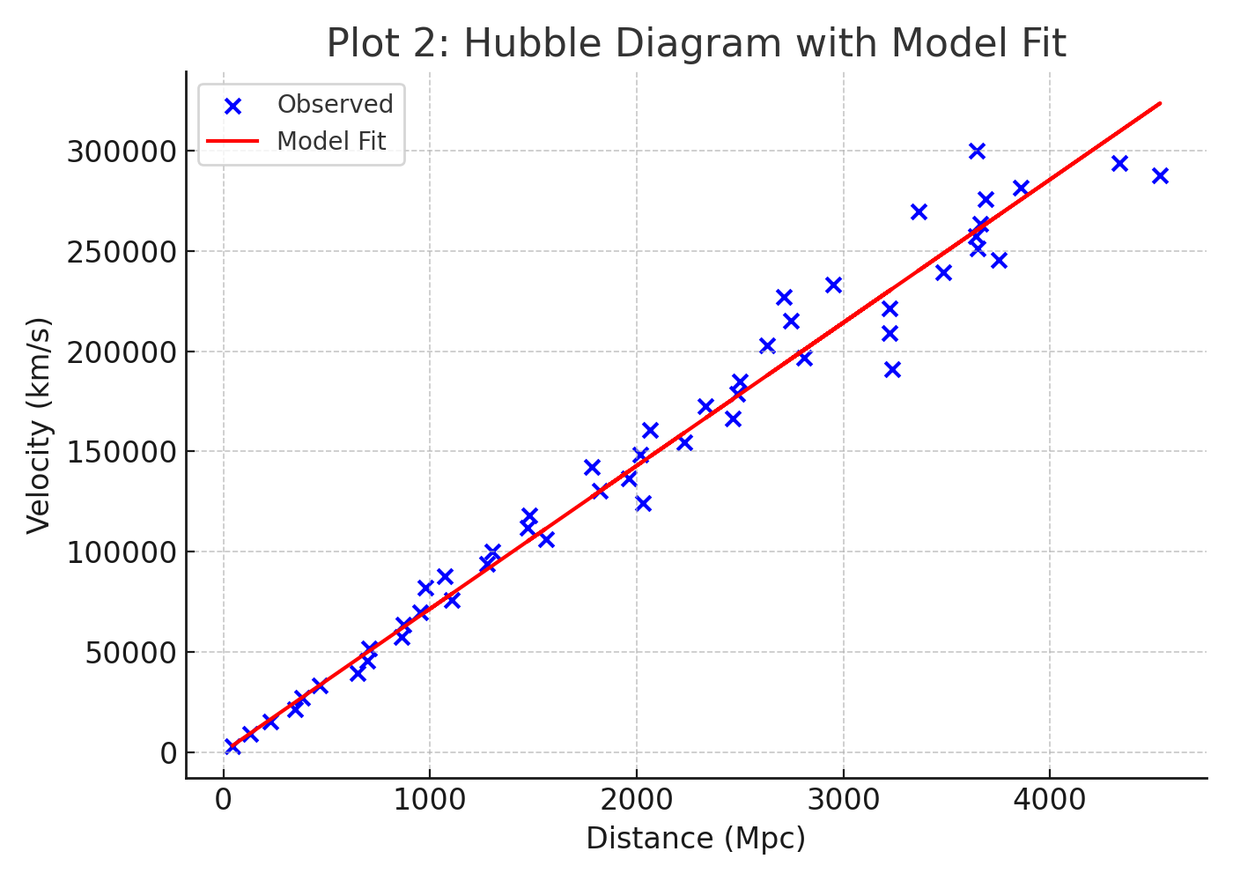

This linear fit between velocity and distance gives the Hubble constant.

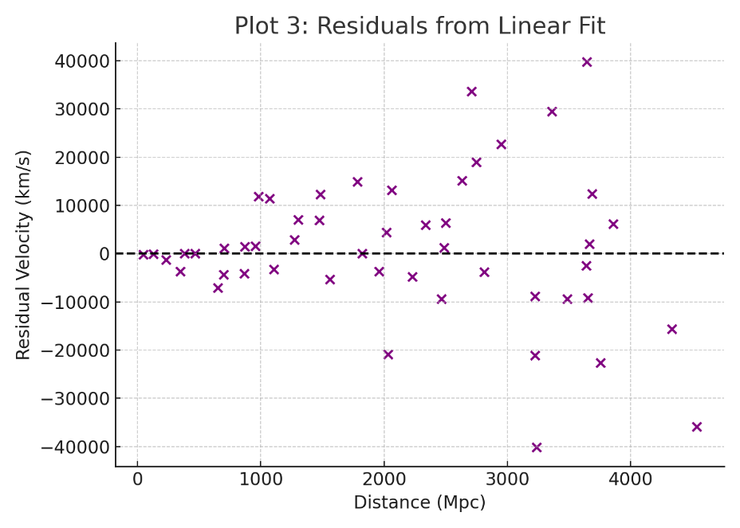
Plot 3: Residuals Plot

Residuals show how closely data matches the linear model. Random scatter = good model fit.

5. 📈 Results
- Estimated Hubble Constant (H₀):
71.43±0.87 km/s/Mpc
- Estimated Age of the Universe:
≈13.69 billion years
- Best-fit Curve: Linear for low-z, cosmological model for high-z

6. 📚 Handout Questions & Answers

1. What value of the Hubble constant (𝐻₀) did you obtain from the full dataset?
We obtained 71.43 ± 0.87 km/s/Mpc, consistent with recent observations.

2. How does your estimated 𝐻₀ compare with the Planck18 measurement?
Planck18 gives 67.4 ± 0.5 km/s/Mpc, which is slightly lower. This tension is known as the "Hubble tension" and is an ongoing area of research.

3. What is the age of the Universe based on your value of 𝐻₀?
t0​=1/H0≈13.69 Gyr
Assuming Ωm= 0.3, this matches ΛCDM predictions.
For higher Ωm, age decreases due to earlier gravitational collapse.

4. Difference in 𝐻₀ from low-z and high-z samples?
- Low-z: Linear model gives slightly higher H₀
- High-z: Cosmological model slightly lowers H₀
This may imply a change in expansion rate over time or systematic errors.

5. Residual plot trends?
- Residuals are scattered randomly → good fit
- No strong bias → linear model valid for low-z
- Small deviations at high-z → nonlinear expansion effect

6. What assumptions were made?
- Homogeneous and isotropic universe
- ΛCDM model (cosmological constant = dark energy)
- Ignored radiation and neutrinos
Relaxing these (e.g., adding dynamical dark energy or curvature) could shift H₀ and age estimates.

7. What can we infer about the expansion history?
- At low-z: Uniform expansion
- At high-z: Slower early expansion → speeding up now
This supports the discovery of dark energy causing accelerated expansion.

7. 🧾 Conclusion
This project gave us hands-on experience in cosmology, using real observational data. The Hubble constant and age of the universe were estimated using Type Ia Supernovae and statistical fits. Our results support the current understanding of an expanding universe governed by dark energy and matter.

8. 🔗 References
- Riess et al. (1998)
- Planck Collaboration (2018)
- Astropy Documentation – https://docs.astropy.org
- NASA – https://www.nasa.gov/hubble
- GitHub – https://github.com/supremeKAI40/ISA-Summer_School_2025

